**Experiment 2**

**Aim:** To implement insertion sort algorithm and plot the graph on its execution time.

**Code:**

#include <iostream>

#include <ctime>

using namespace std;

int pass=0,comp=0,swaps=0;

void Insertion_Sort(int *a, int n){

for(int i=1;i<n;i++){

pass++;

int temp = a[i];

int j = i-1;

while(j>=0){

comp++;

if(temp<a[j]){

a[j+1]=a[j];

swaps++;

}

else{

break;

}

j--;

}

a[j+1]=temp;

}

}

int main(){

int n;

clock_t s,f;

cout<<"Insertion Sort Algorithm"<<endl;

cout<<"Best Case Time Complexity is: O(n)"<<endl;

cout<<"Worst Case Time Complexity is: O(n^2)"<<endl;

cout<<"Space Complexity is: O(n)"<<endl;

cout<<"Enter the size of an array: ";

cin>>n;

int *arr = new int [100];

cout<<"Enter the array elements: ";

for(int i=0;i<n;i++){

cin>>arr[i];//=rand()%100;

}

cout<<"The original array is: ";

for(int i=0;i<n;i++){

cout<<arr[i]<<" ";

}

cout<<endl;

s=clock();

//cout<<s;

Insertion_Sort(arr,n);

f=clock();

//cout<<" "<<f<<endl;

cout<<"The sorted array in ascending order is: ";

for(int i=0;i<n;i++){

cout<<arr[i]<<" ";

}

cout<<endl;

cout<<"No of passes is: "<<pass<<endl;

cout<<"No of comparisons is: "<<comp<<endl;

cout<<"No of swaps is: "<<swaps<<endl;

//cout<<"The time required for insertion sort is: "<< ((double)(f-s))/CLOCKS_PER_SEC <<" seconds."<<endl;

delete arr;

}

**Output:**

1. **Best Case:**

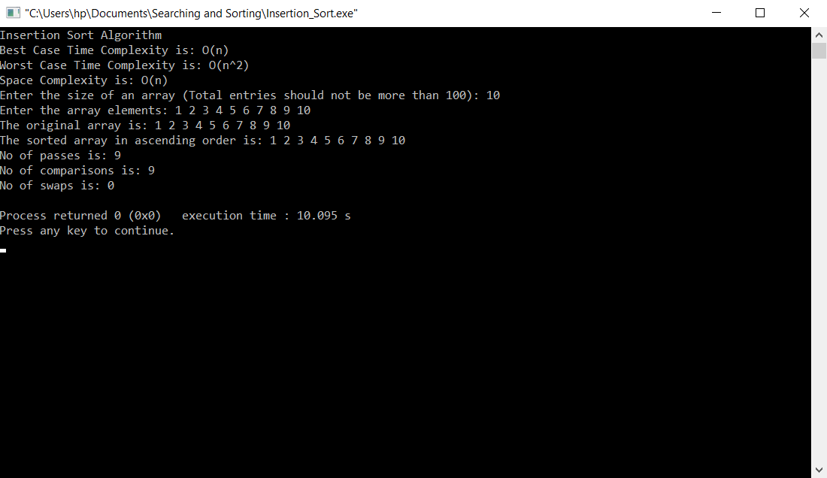

1. **Worst Case:**

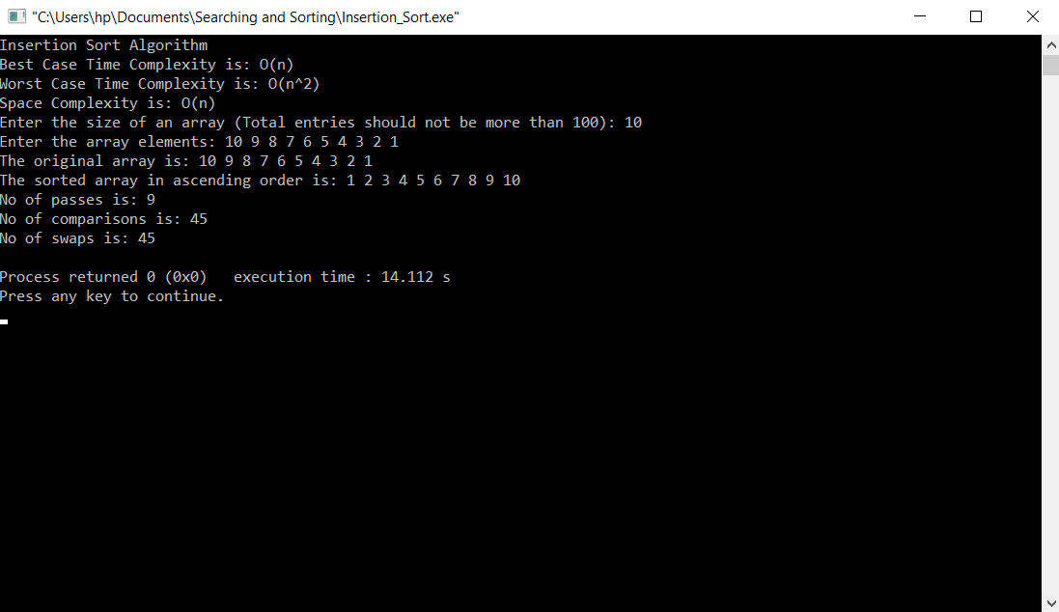

**Analysis:**

|  |  |
| --- | --- |
| Entries | Time Taken (seconds) |
| 10 | 0 |
| 50 | 0 |
| 100 | 0 |
| 500 | 0 |
| 1000 | 0 |
| 5000 | 0.015 |
| 10000 | 0.1 |
| 50000 | 2.21 |
| 100000 | 8.134 |
| 500000 | 233.036 |

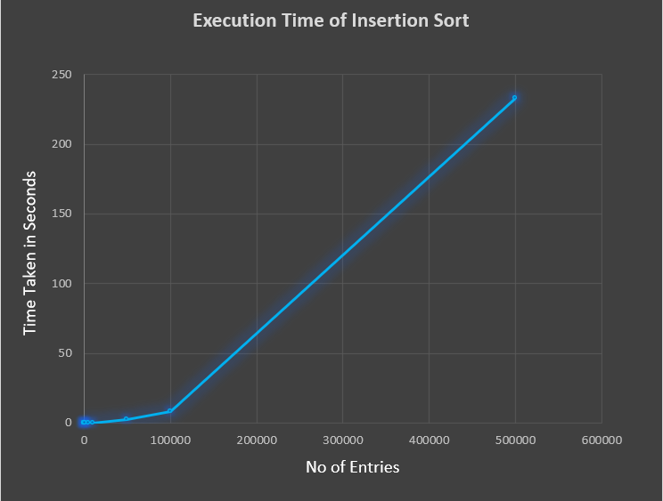

**Conclusion:** The insertion sort sorting algorithm has been implemented and analysed successfully.